**Faculty of Engineering, University of Jaffna**

**Department of Computer Engineering**

**EC5080: Software Construction**

**Assignment 03**

**(Laboratory assignment II- 2 Hours)**

Task: (40 marks)

Design a calculator that can handle the operations of the following sample figure. You can add more features and facilitate other operations.

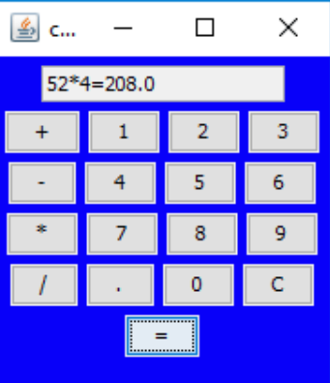

Marks allocations:

Basic operations: 20 Marks

Interface style (color, etc.) and usability: 10 Marks

Added features and operations: 10 Marks (E.g: %, brackets, order of operands, etc)